CHARACTERIZATION LAB

Experiment: 3

Characterization of CS amplifier

Sounak Mandal

19EC10088

Aim

The aims of the experiment are:

1. To determine the DC characteristics of NMOS transistor.
2. To determine the gain and frequency response of CS amplifier.

Theory

MOS is the first choice in integrated circuits because of their very low power consumption. This is in spite of the fact that they have low. MOS is used as both switch as well as amplifier. The common source topology takes input at the gate terminal and gives output at the drain terminal.

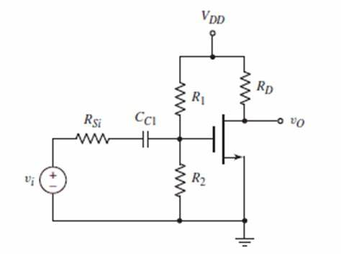

Observations and Calculations

1. **DC characteristics: Plot IDS vs VDS. Plot for five different values of VGS: VGS = 0.6V, 0.9V,1.2V, 1.5V and 1.8V.**

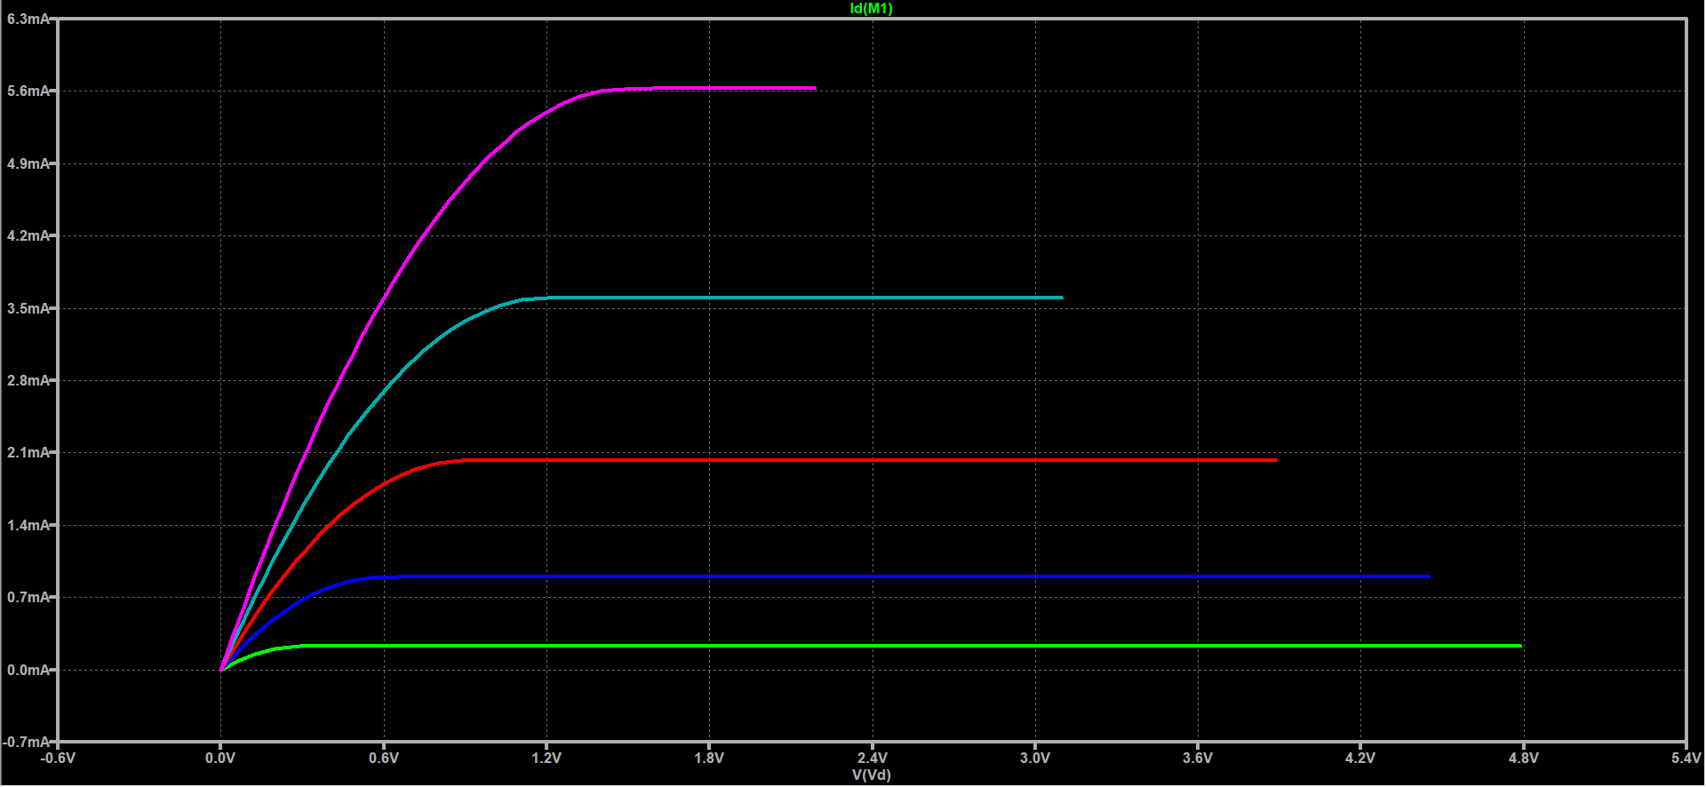

1. **DC operating Point: Find the DC operating point and check whether the circuit is in saturation or not**.

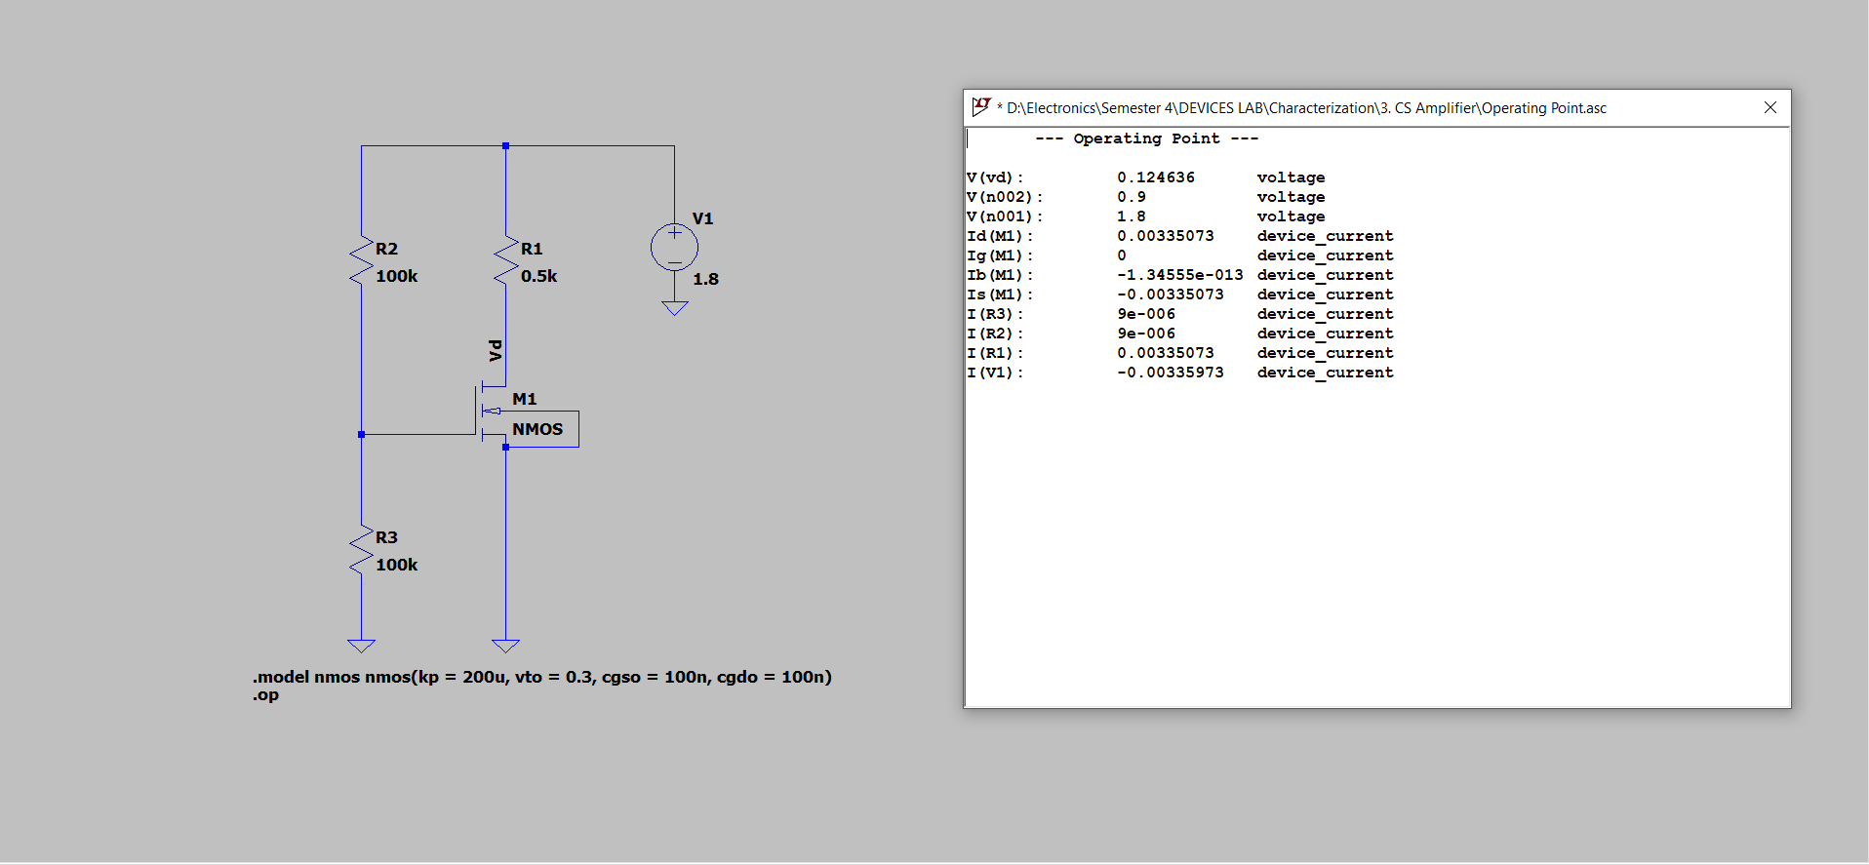

From the results of dc operating point, we see that the transistor is in linear or triode region. It is not in saturation.

1. **Common Source Amplifier**

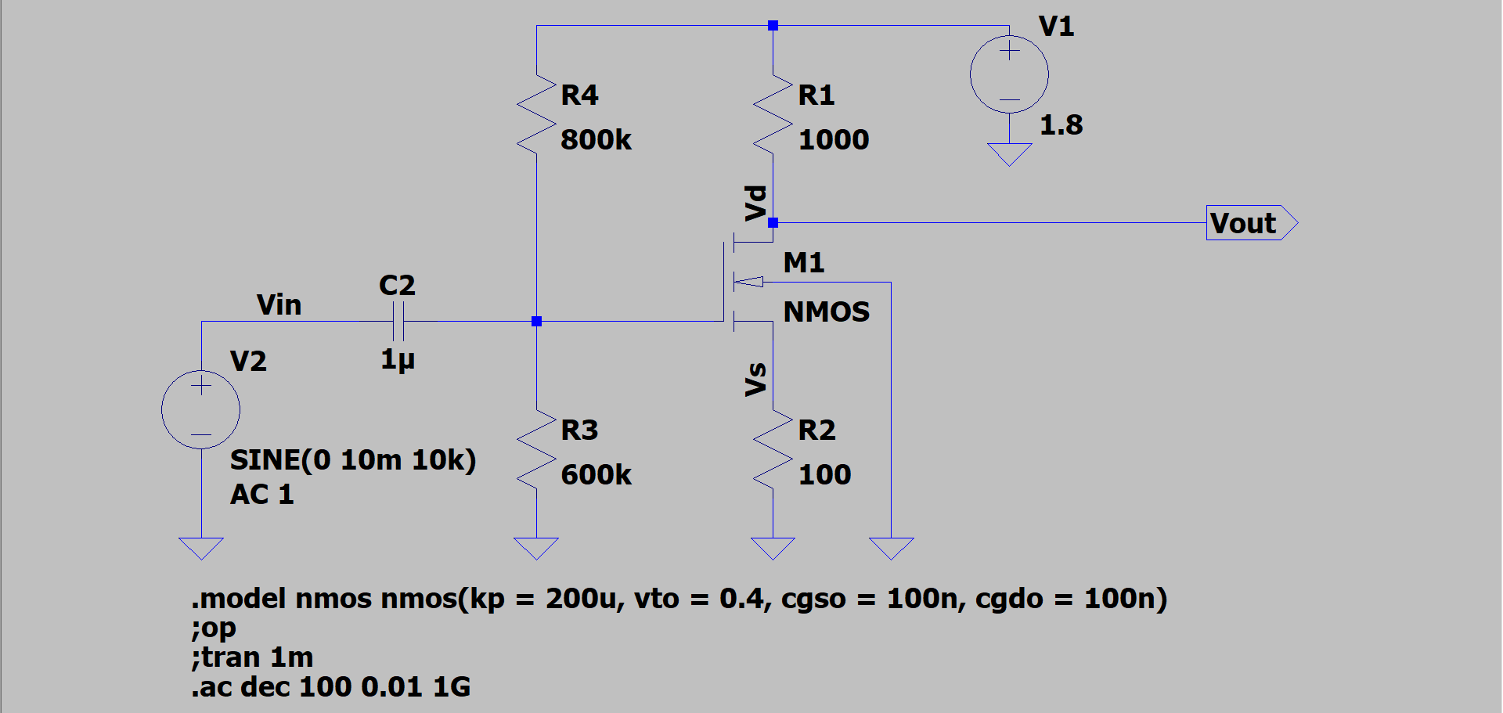

1. **Apply sine wave (20mVpp, 10 kHz) through a capacitor 0.1 μF. Plot input and output signal with respect to time. Output is measured at Drain of MOSFET (with and without a capacitor 0.1 μF connected at Drain of MOSFET). Take Rs=0 ohm and also Rs=100 ohm.**

**Rs = 100 Ohm and No capacitor**

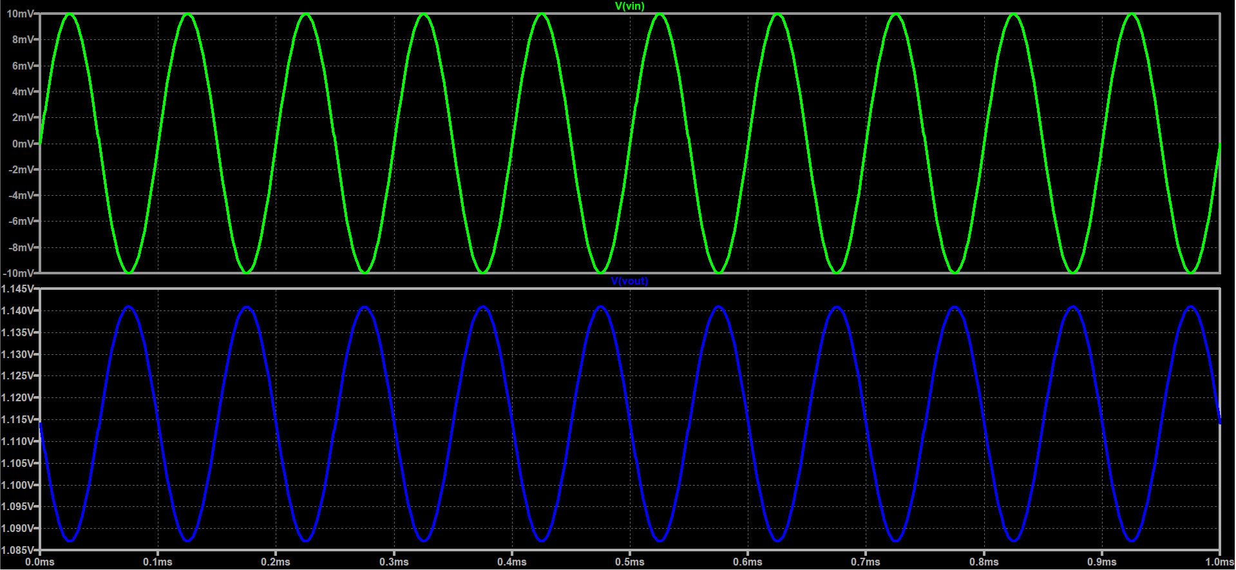

**Rs = 100 Ohm and capacitor**

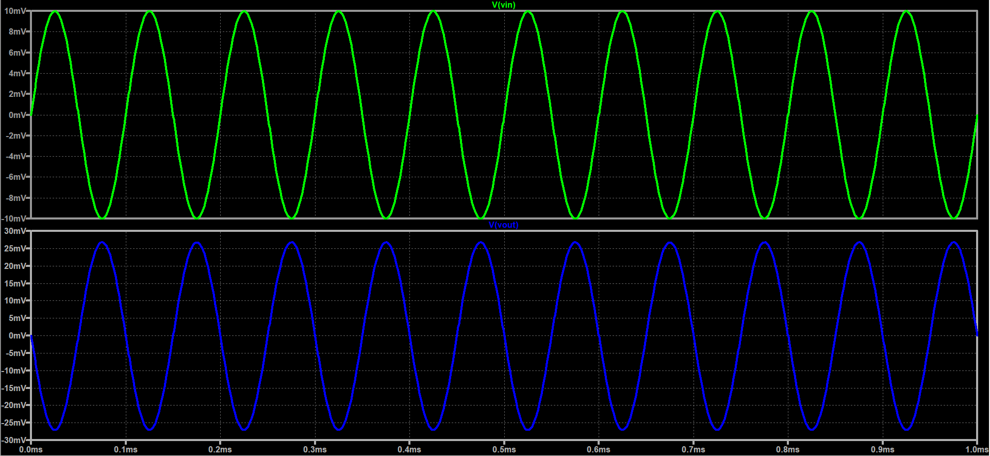

**Rs = 0 Ohm and No capacitor**

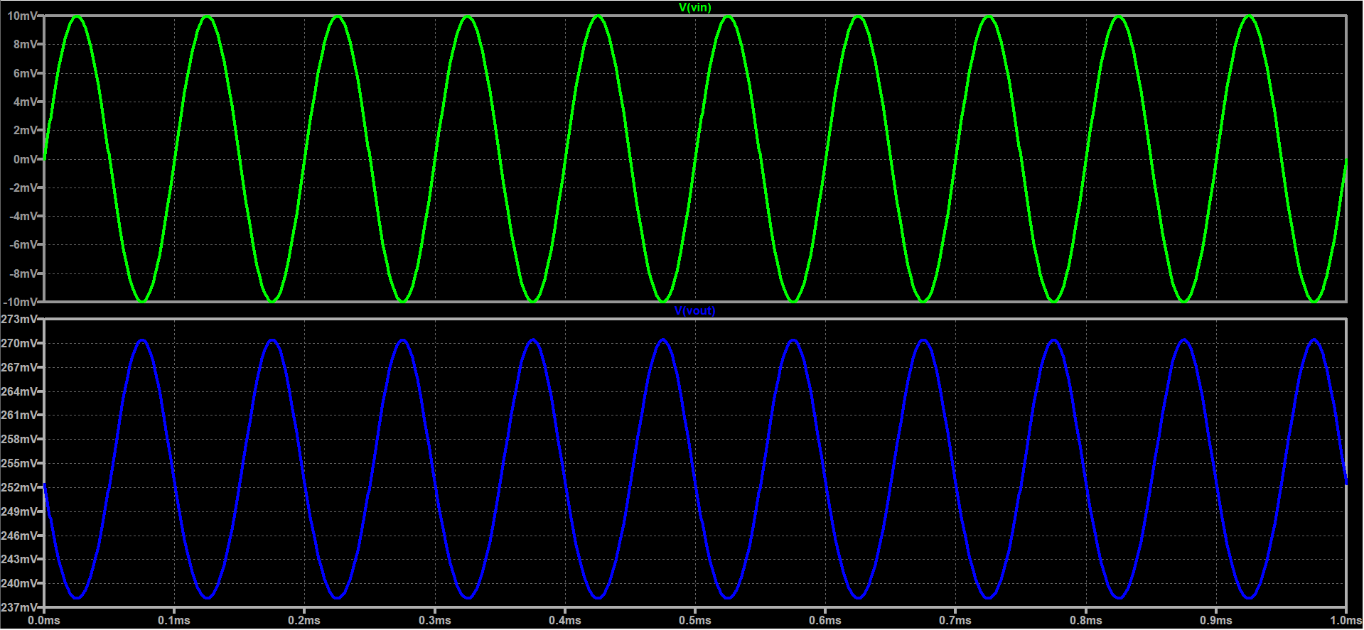

**Rs = 0 Ohm and capacitor**

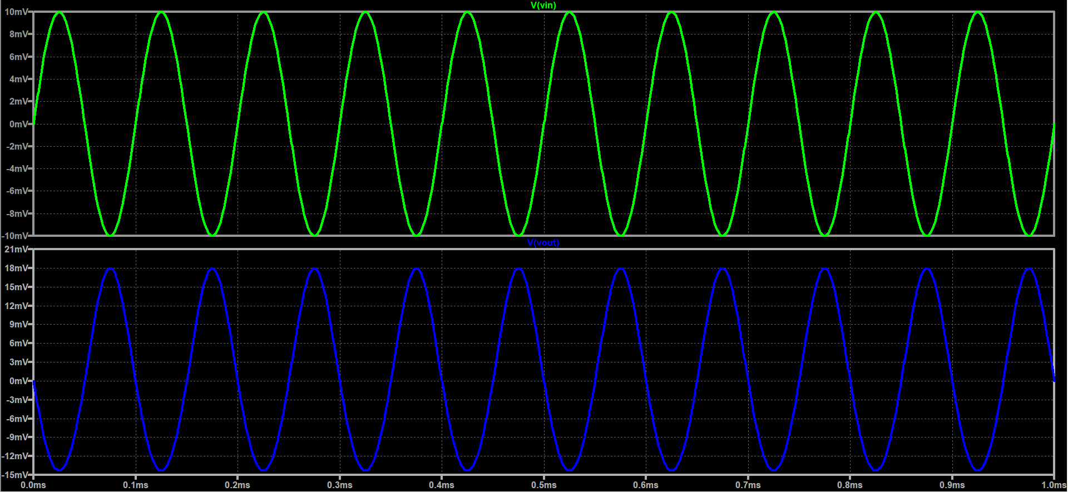

1. **Plot Gain vs Frequency, take Rs=0 ohm and find bandwidth.**

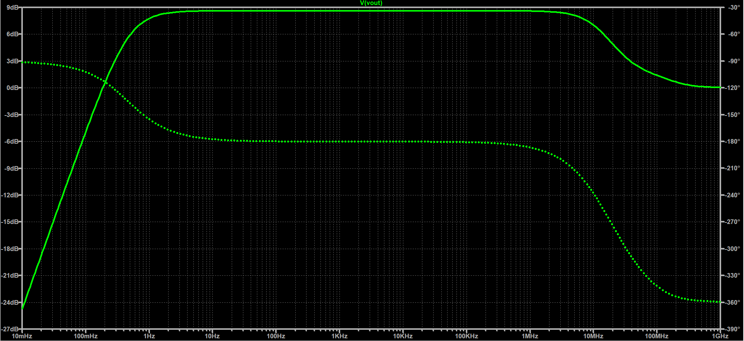

The above plot shows that the -3 dB cutoff frequency is around 111.61MHz. Since lower cutoff will be very low the bandwidth is 111.61 MHz.

1. **Repeat the plot (ii) by changing RD = 1 kΩ, take Rs=0 ohm.**

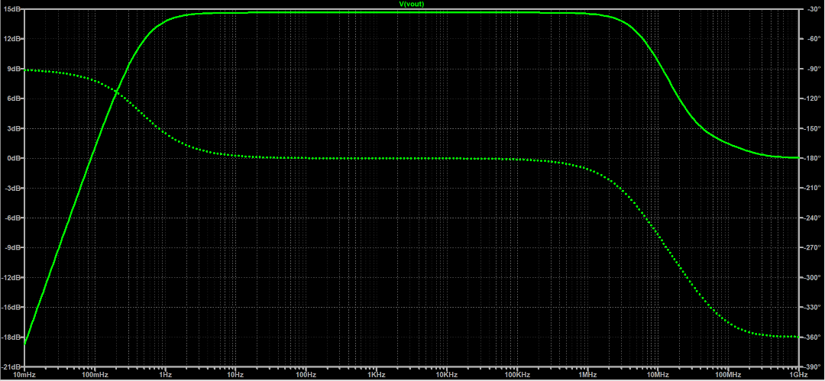

1. **Discuss the effect of RD and RS on gain.**

The expression for gain in terms of resistances is

$$\left|A_{v}\right|=\frac{R_{d}}{\frac{1}{g_{m}}+R_{s}}$$

According to the formula, the gain increases with Rd and decreases with Rs. The increase with Rd can be ascertained from the bode plot’s midband gain.

Discussion

1. MOSFETs are low gain devices which is in direct contrast to BJT. This is a direct consequence of the square dependence of current on voltage as compared to BJT which has exponential dependence.
2. The CS topology is an inverting amplifier, the output and input are 180° out of phase in midband region.
3. MOSFETs have very low power consumption, is very fast in switching and can be scaled down to smaller sizes much easily than BJTs. Hence it has become the transistor of choice in modern ICs.

Result

|  |  |  |  |  |
| --- | --- | --- | --- | --- |
| Rd (Ohm) | Rs (Ohm) | DC Offset at output (V) | Midband Gain (dB) | Bandwidth (MHz) |
| 500 | 0 | 0.254 | 4.016 | 111.61 |
| 500 | 100 | 1.113 | 8.617 | 16.271 |
| 1000 | 100 | 0.427 | 14.637 | 6.71 |